Assignment – 2

**1)Connect to the Store Sales Data and do the following: -**

− Remove all the blank rows. − Update the column header if they are not updated − Create a text table and show the sales in terms of o Customers o Product Category o Regions

**Step 1:** From POWER BI Desktop🡪Get Data source🡪Select the Dataset(Excel)🡪From Power BI Query Editor🡪Transform Data of 3 Tables🡪From orders table Remove null values in rows and Make headings using🡪Use First row as Headers

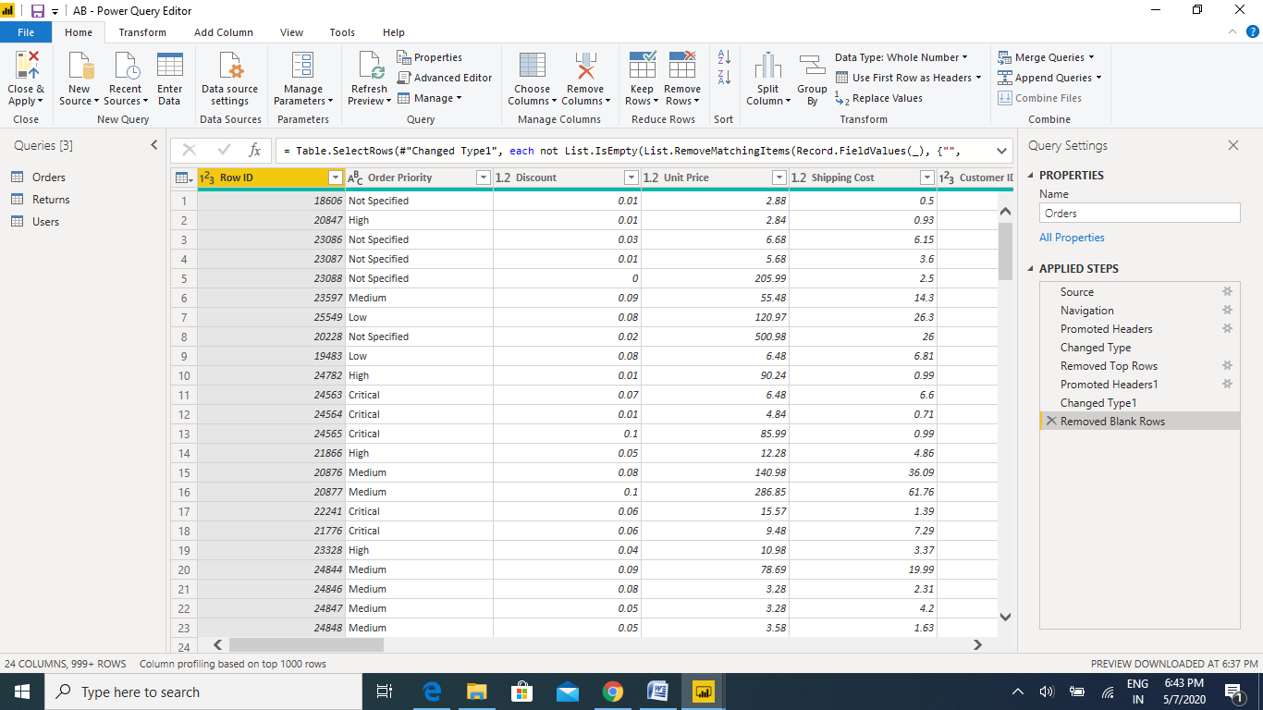

**Steps 2:** Click on Apply and Close

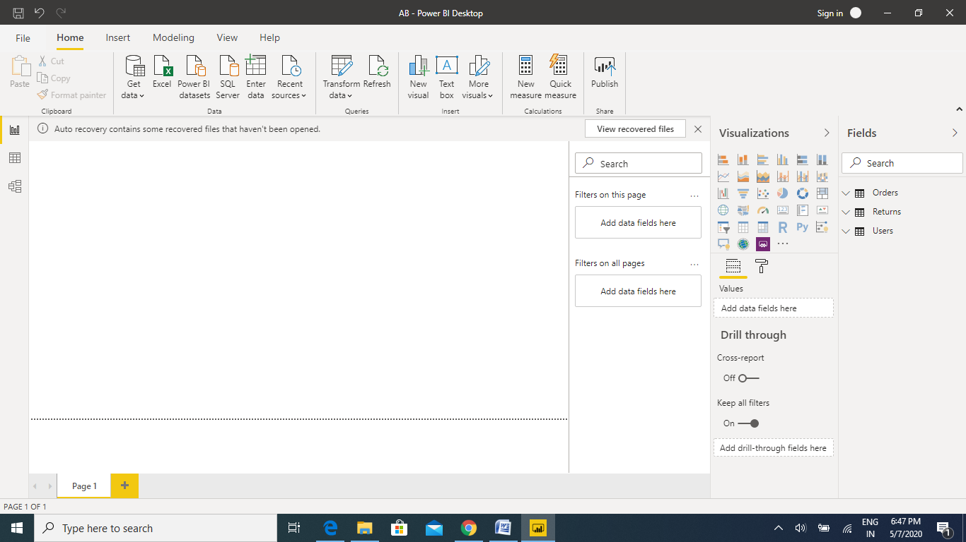

**Step 3: From visualization Select Text table and will see the sales details**

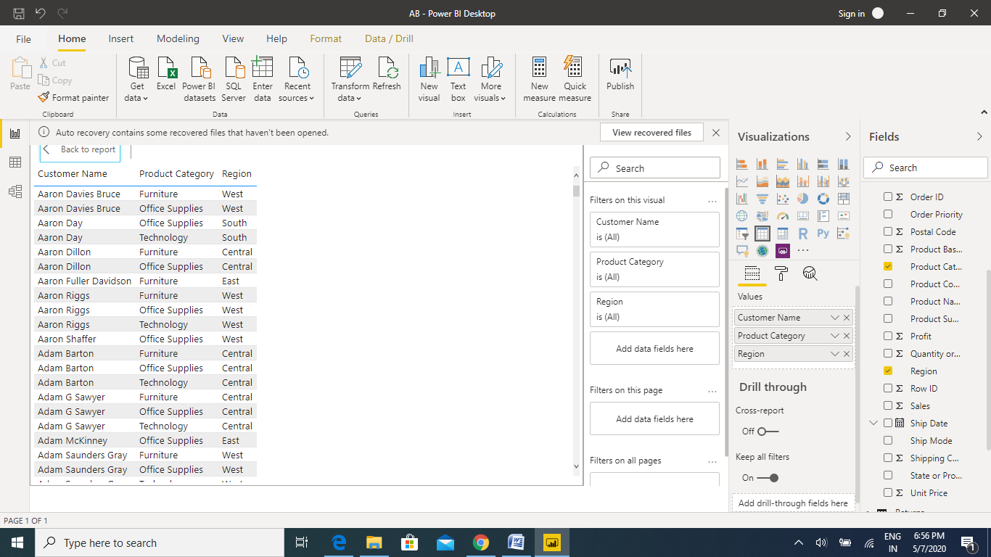

**2) Create a line and Clustered Column Chart showing the Sales and Discount as per the State or Province**

− Format the bars and line with different colors − Which state has the highest sales in terms Technology

**Data Visualization:**

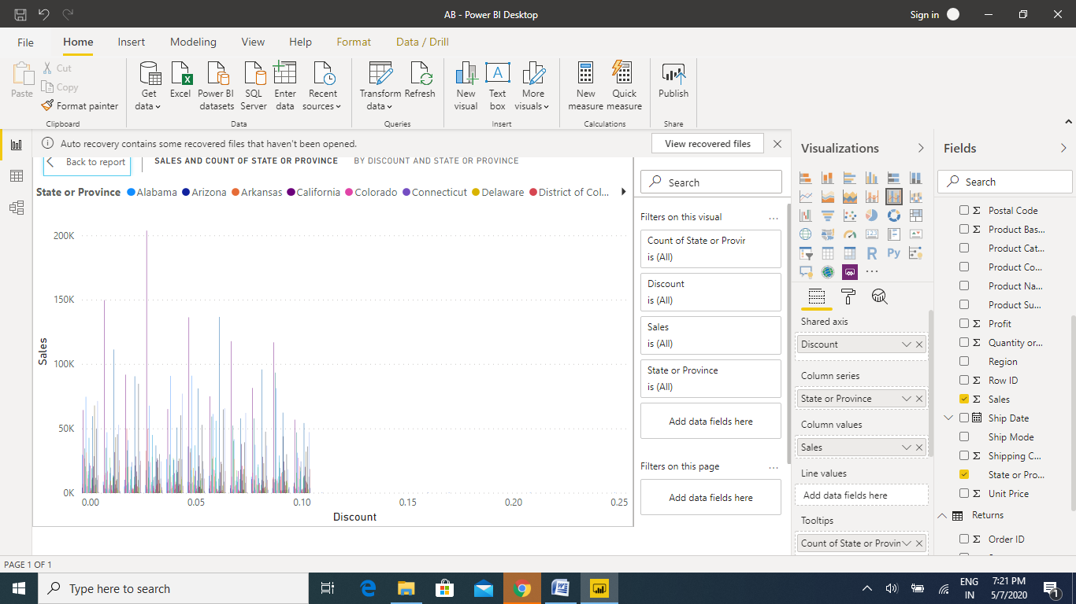

**3) Create a Donut Chart showing sales in terms of Product category**

**SALES BY PRODUCT CATEGORY USING Donut Chart:**

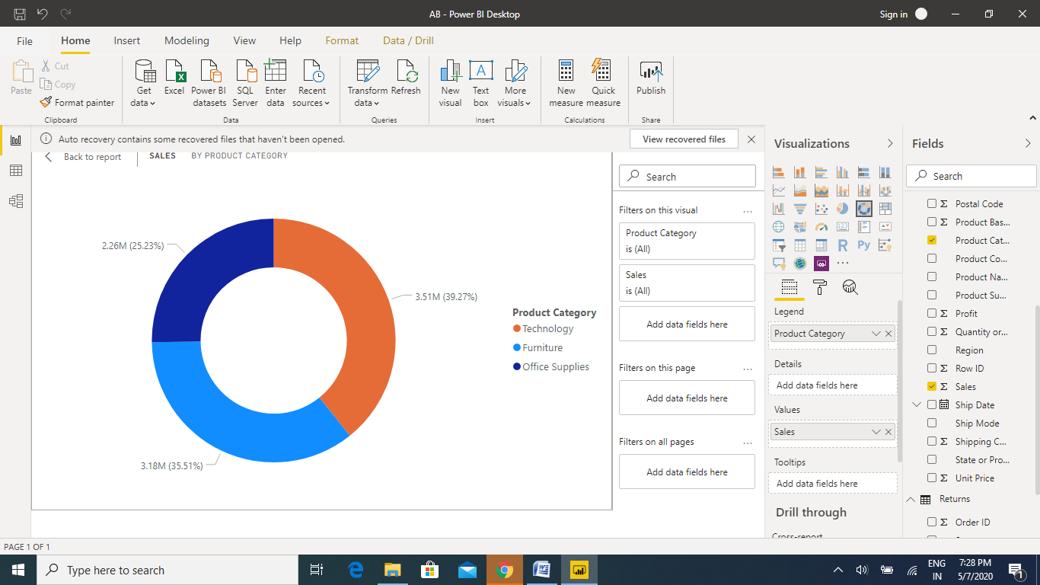

**4) Create a Slicer and show the regions in dropdown. See how all the visuals mentioned above behaving when a particular region is selected.**

**Answer: Finally from the above all questions we found that, when we click on Particular region it show us different behaviours as per region sales etc.,**

